NAV Development Tasks

Dynamics NAV 2016

Version : W1 9.00

Build : 44365

# Client Add-In Development

## Problem:

In NAV 2017 it is not possible to dynamically change the Colour of a text field to a number of colours. Your client, CRONUS Australia Pty. Ltd. , requires the *Name* field of a *Customer Card Page* to change colour should the Customer have different values for the *Blocked* field.

|  |  |
| --- | --- |
| **Blocked Value** | **Name Field Colour** |
| <Blank> | Green |
| Ship | Orange |
| Invoice | Purple |
| All | Red |

## Exercise:

Develop a Custom Client Add-In that will change the background colour of the *Name* field on the *Customer Card* depending on the value of the *Blocked* field

**Objects**

* + Page 21 – Customer Card
  + Add-in : ChangeBGColorAddin.dll

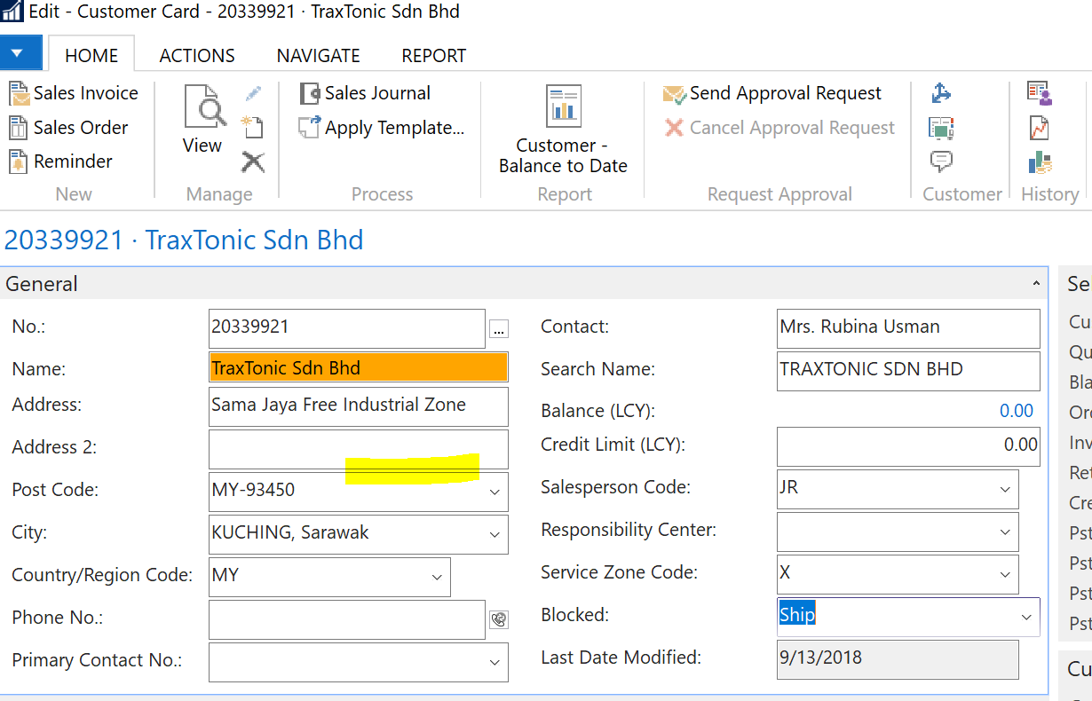

# NAV and SQL Performance

### Problem:

The finance manager at CRONUS Australia Pty. Ltd has reported that NAV is performing poorly and the performance is getting worse over time. He is not forthcoming with any specific detail or functional area.

### Exercise:

What would you do in NAV and on a SQL Server level to determine the cause of the poor performance? Please include any SQL scripts that would be of assistance in your answer.

There are N number to be checked in NAV, SQL to determine what cause the poor performance.

* Check Network, maybe it’s because of slow connection
* Check if Change Logs is activated, then check the size of the table Change Log Entries in NAV
* Enable SQL Tracing in NAV and use SQL Server Profiler
  + Profiler output when executing exercise 1 (change field background color)

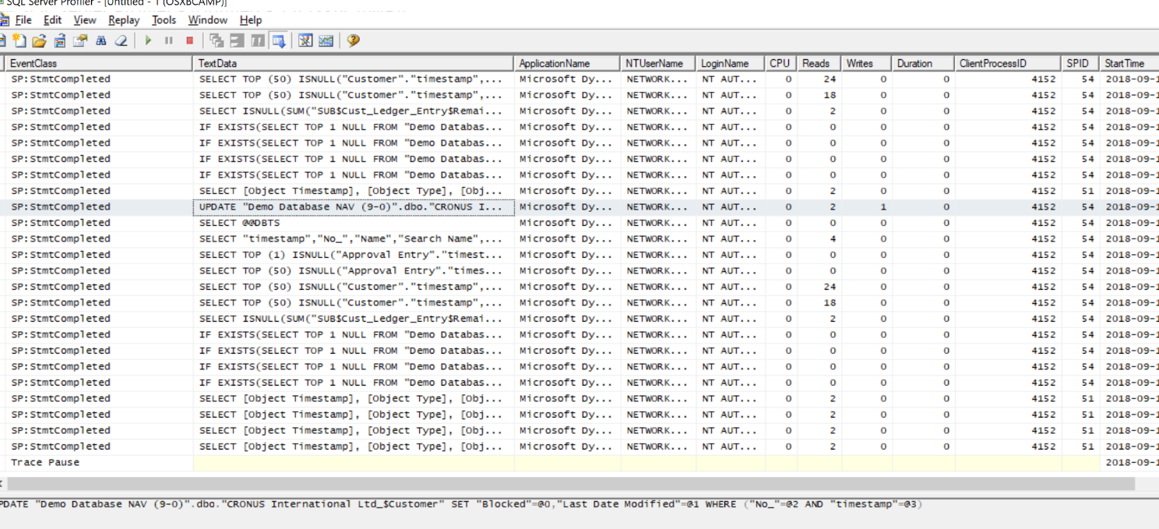

* Run a script in SQL to determine **long running queries** that may affect the performance of NAV

use master

--SET TRANSACTION ISOLATION LEVEL READ UNCOMMITTED

SELECT TOP 20

CAST(qs.total_elapsed_time / 1000000.0 AS DECIMAL(28, 2))

AS [Total Duration (s)]

, CAST(qs.total_worker_time * 100.0 / qs.total_elapsed_time

AS DECIMAL(28, 2)) AS [% CPU]

, CAST((qs.total_elapsed_time - qs.total_worker_time)* 100.0 /

qs.total_elapsed_time AS DECIMAL(28, 2)) AS [% Waiting]

, qs.execution_count

, CAST(qs.total_elapsed_time / 1000000.0 / qs.execution_count

AS DECIMAL(28, 2)) AS [Average Duration (s)]

, SUBSTRING (qt.text,(qs.statement_start_offset/2) + 1,

((CASE WHEN qs.statement_end_offset = -1

THEN LEN(CONVERT(NVARCHAR(MAX), qt.text)) * 2

ELSE qs.statement_end_offset

END - qs.statement_start_offset)/2) + 1) AS [Individual Query]

, qt.text AS [Parent Query]

, DB_NAME(qt.dbid) AS DatabaseName

, qp.query_plan

FROM sys.dm_exec_query_stats qs

CROSS APPLY sys.dm_exec_sql_text(qs.sql_handle) as qt

CROSS APPLY sys.dm_exec_query_plan(qs.plan_handle) qp

WHERE qs.total_elapsed_time > 0

ORDER BY qs.total_elapsed_time DESC

# C/AL Development

### Exercise

Your new client CRONUS Australia Pty. Ltd (a leading bicycle manufacturer) has recently purchased NAV. All users use the NAV Role Tailored Client. As part of her job Susan, the Sales Order Processor, needs to import large Sales Orders (of 25 lines or more) from an external system. There will only ever be one Sales Order per XML file. Some customers would telephone CRONUS and request that Susan send them an Order Confirmation via email. The Sales Order Confirmation report is customised to suit a specific layout for Cronus.

### Part 1 – XMLport

Develop an XMLport for Susan that can be used to import and create Sales Orders from an XML file. The format of the file would be as follows

**Objects**

* + XMLPort 50000 – Import Sales Order
  + Page 9305 – Sales Order List

Sales Orders -> Actions -> Import & Send PDF -> Import XML Sales Order

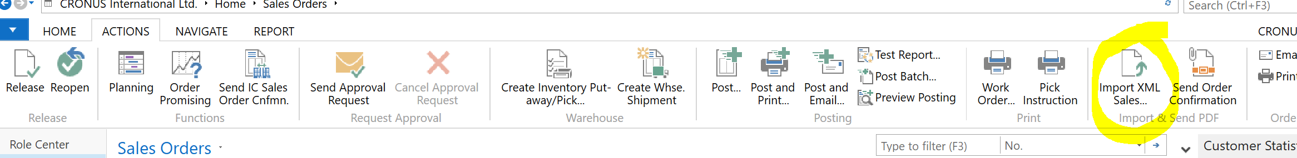

### Part 2 – Sales Order Confirmation

Customise the standard Sales Order Confirmation to look the format that the client has requested below

**Objects**

* + Report 205 – Order Confirmation

See **101016.pdf** file for sample output.

### Part 3 – Send the Order Confirmation via Email

Create a function send a copy of the Sales Order Confirmation as a pdf attachment to a customer using Microsoft Outlook.

**Objects**

* + Page 9305 – Sales Order List

Sales Orders -> Actions -> Import & Send PDF -> Send Order Confirmation

